***Agriculture in India***

***Indian Institute of Remote Sensing (IIRS), Dehradun***

***M.Sc Agriculture Analytics***

*Name: - Ponkiya Harshilkumar J.*

*Module Name: - Programming for Geodata Processing*

*Student ID: - 202319002*

*IIRS Registration No: TS90705*

***Abstract***

This project presents proof and explanations supporting THE ECONOMIC TIMES article which reports " Share of agriculture in India's GDP declined to 15% in FY23: Govt ".

This shift shows a transformation towards a bigger diversified economy with different sectors making more contributions. However, it's essential point to note that this lower agricultural percentage does now not always suggest a decline within the sector's average overall performance.

I support the article's findings and believe that the forecast for India's economic growth is accurate. I plan to create visual representations of this data to demonstrate how the article's predictions are likely to come true.

The datasets were taken from the website “India Budget”, like Agricultural Crops Production, Crops Area(Acreage), and Production of Livestock Products and Fish statistics for the years 2012-2022.

This indicates that at the same time as agriculture's proportional contribution to the country-wide economic system is lowering, the sector itself stays dynamic and robust.

It is crucial to recognize the intricate dynamics of the evolving agricultural landscape on the way to formulate policies that not only sustain the sector's growth but also address the challenges faced by farmers.

***Introduction and Datasets***

1. **Agricultural Crops Production in India**

* The mentioned dataset is from the website India Budget.
* Data includes Agricultural Crop production in Million Tones from the year 2012 to 2022.
* The provided dataset consists of 23 distinct crop production data presented as time-series data.
* Link for the given dataset. <https://www.indiabudget.gov.in/economicsurvey/doc/Statistical-Appendix-in-English.pdf>
* Economic Survey 2022-23 Statistical Appendix | Page No. 34
* The given dataset is in PDF Format, so I converted it to Excel format.

1. **Agricultural Crop Area in India**

* The mentioned dataset is from the website India Budget.
* The following data pertains to crop area sown in million hectares between the years 2012 to 2022.
* The dataset provided consists of time-series data for 23 distinct crop areas.
* Link for the given dataset. <https://www.indiabudget.gov.in/economicsurvey/doc/Statistical-Appendix-in-English.pdf>
* Economic Survey 2022-23 Statistical Appendix | Page No. 35
* The given dataset is in PDF Format, so I converted it to Excel format.

1. **Production of Major Livestock Products and Fish**

* The mentioned dataset is from the website India Budget.
* Data includes the Production of Major Livestock Products and Fish from the year 2012 to 2022.
* The provided dataset consists of three distinct types of data in the form of time series.
* Link for the given dataset. <https://www.indiabudget.gov.in/economicsurvey/doc/Statistical-Appendix-in-English.pdf>
* Economic Survey 2022-23 Statistical Appendix | Page No. 45
* The given dataset is in PDF Format, so I converted it to Excel format.

***Research Question***

I have read an article in “The Economics Times” which claims that the share of agriculture in India's GDP is expected to decline to 15% by FY23, as per the government's report. I support the article's findings and believe that the forecast for India's economic growth is accurate. I plan to create visual representations of this data to demonstrate how the article's predictions are likely to come true.

CLAIM: “The Indian Agriculture Sector Continuously growing at a sturdy rate.”

**Article Link:**

[https://economictimes.indiatimes.com/news/economy/agriculture/share-of-agriculture-in-indias-gdp-declined-to-15-in-fy23 govt/articleshow/106124466.cms?utm_source=contentofinterest&utm_medium=text&utm_campaign=cppst](https://economictimes.indiatimes.com/news/economy/agriculture/share-of-agriculture-in-indias-gdp-declined-to-15-in-fy23%20govt/articleshow/106124466.cms?utm_source=contentofinterest&utm_medium=text&utm_campaign=cppst)

Questions that must be answered:

1. **Why Share of agriculture in India's GDP declined to 15% in FY23:**

According to the authorities, the agriculture sector's contribution to India's GDP has declined from 35% in 1990-1991 to 15% in 2022-23. This decline is not due to a decrease in agricultural GVA but due to the rapid growth of the commercial and service sectors. The overall Gross Value Added (GVA) of the economy has been impacted by this shift in the proportion of agriculture in GVA.

1. **Recent Trends in Agriculture:**

India’s agriculture mainly depends on nature. However, changing climate and global warming are making farming unpredictable. The need to use modern technologies to increase productivity and profitability has therefore led to the adoption of Agriculture 4.0 in India.

Agriculture 4.0 is an improved version of precision farming that has the potential to revolutionize the current farming techniques. Precision farming is a comprehensive approach that aims to maintain the health of the land and soil by enhancing the quality and quantity of yield while causing minimum harm to the environment, as suggested by experts.

***ANALYSIS:***

* **Agriculture Crops Production analysis with Pandas and Matplotlib.**

* To begin with, we have imported the Pandas and Matplotlib libraries into our Python environment.
* 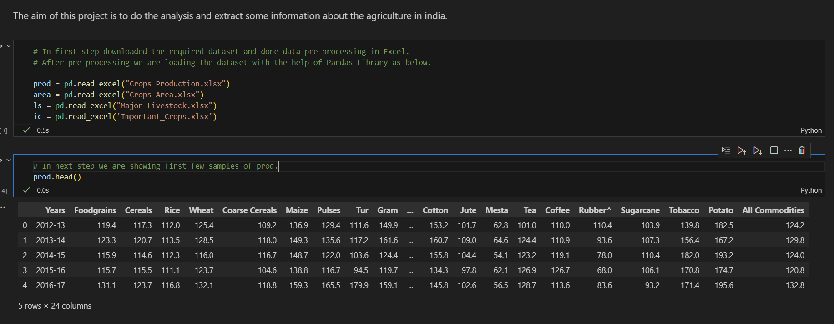We proceeded by reading data from our datasets, which can be seen in the snapshots provided below.
* Next, we will write a code to plot the agricultural production data from 2012 to 2022.
* We extract data crop-wise before plotting, as demonstrated below.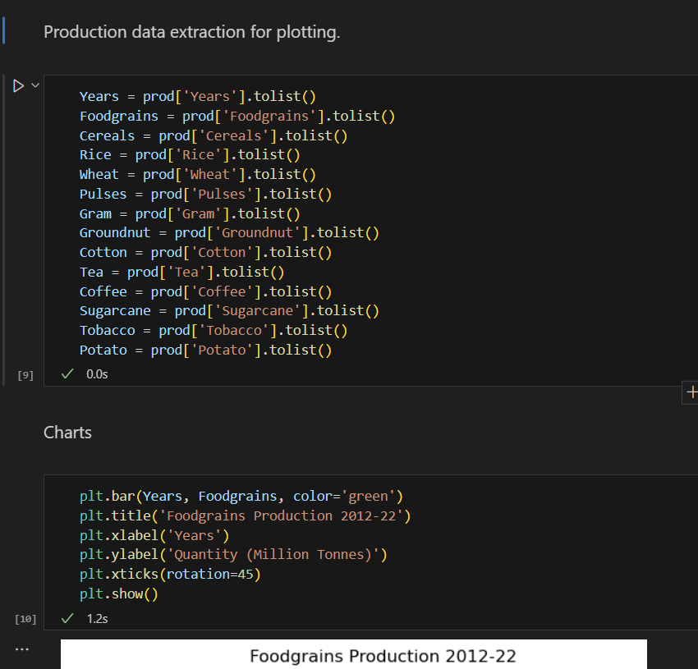

***Results:***

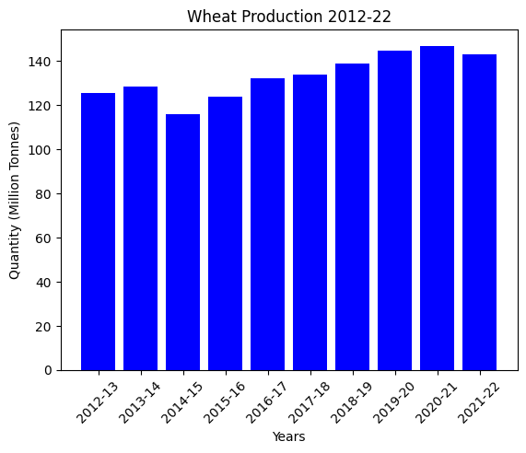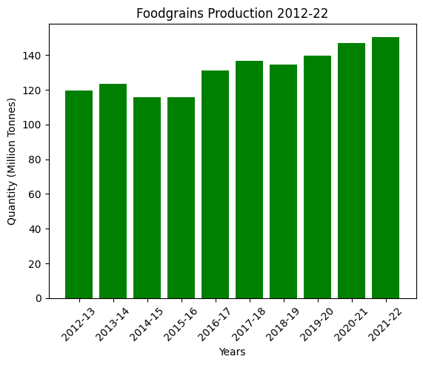

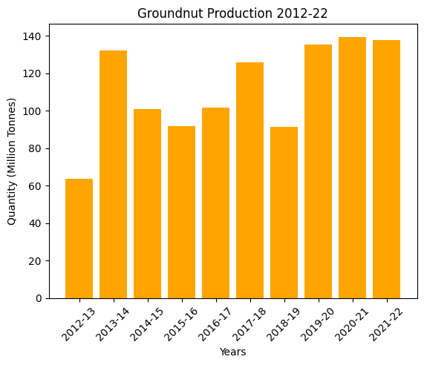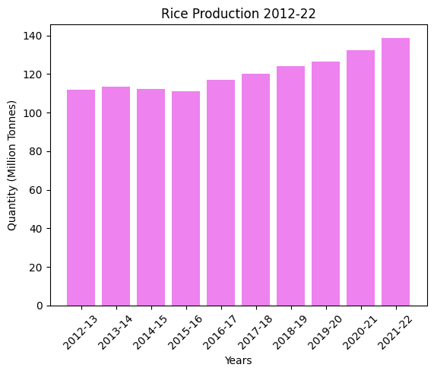

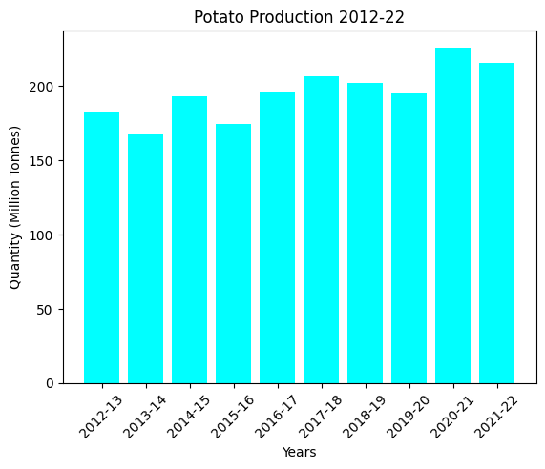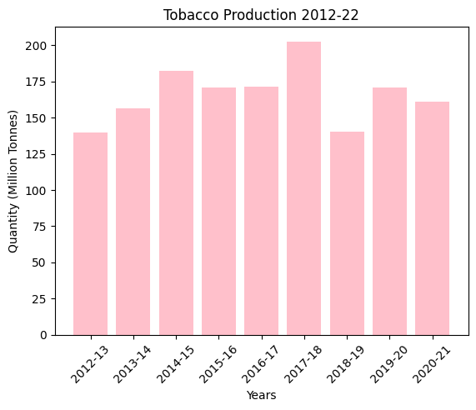

* According to the plots, all crops have shown an increase in production.
* After analyzing the trend in agricultural production, we are now Analyzing crop areas.
* Crop areas are being analyzed using line charts, as shown below, to identify patterns.

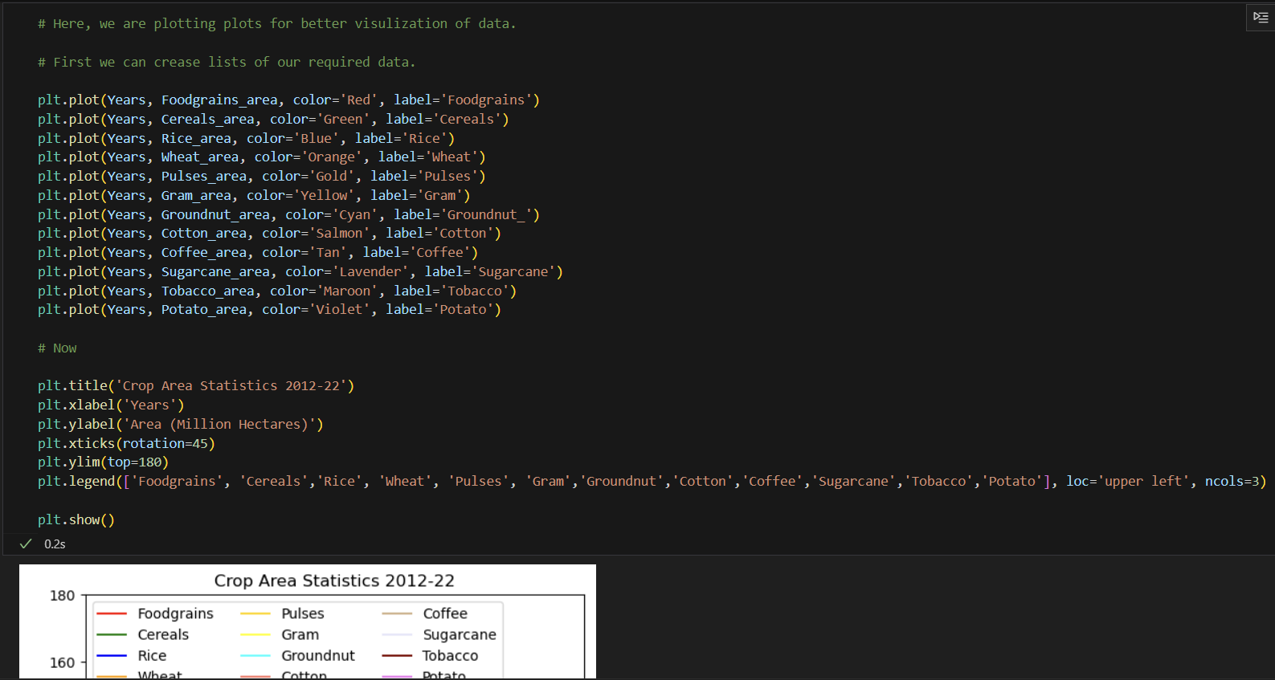

***Results:***

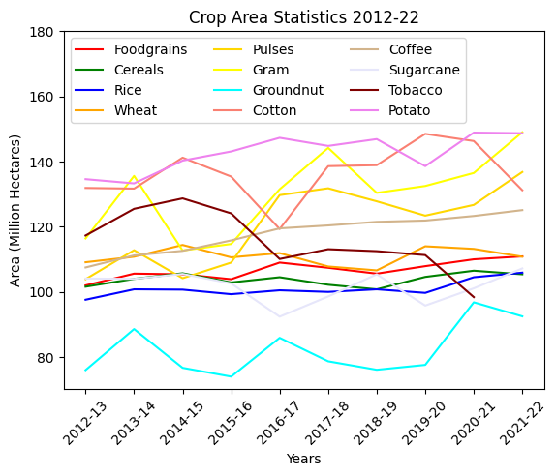

* Crop cultivation is showing a positive trend in Indian agriculture.
* Now, I am analyzing the production of major livestock products and fish.
* As shown in the below Snapshot, group charts plotting patterns in the production of major livestock products and fish.

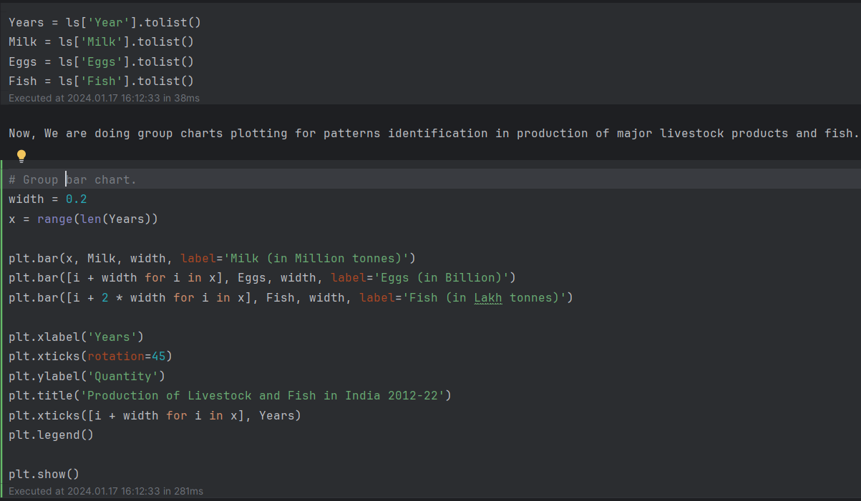

***Results:***

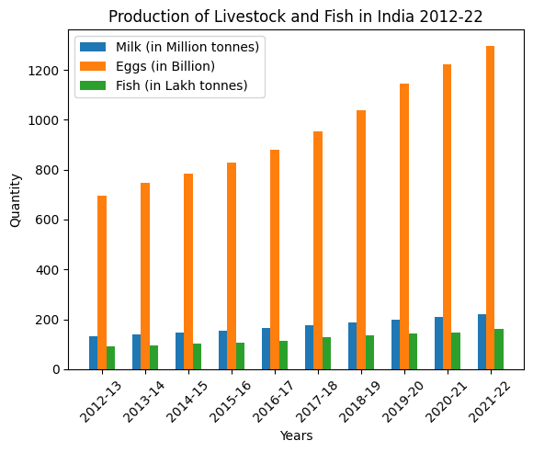

***Conclusion***

* The sustained growth in Agriculture production highlights the sector's capability to adapt to continuously changing situations, adopt technological improvements, and meet the demands of a growing population.
* Although the share of agriculture in the world's GDP has declined to around 4% over the years, the production of crops, livestock products, and agricultural crop area has not shown any decreasing trend similar to the GDP rate.
* Formulating policies for sustainable agricultural growth requires understanding complex dynamics and addressing challenges faced by farmers.
* As India continues to expand its economy, it is crucial for policymakers to strike a balance between promoting industrialization and ensuring the welfare of the agricultural sector.
* My analysis of the project reveals that the agriculture sector is showing an increasing trend.

***Reference Articles:***

1. <https://economictimes.indiatimes.com/news/economy/agriculture/share-of-agriculture-in-indias-gdp-declined-to-15-in-fy23-govt/articleshow/106124466.cms?from=mdr>
2. <https://timesofindia.indiatimes.com/blogs/truth-lies-and-politics/indian-agricultural-sector-on-the-verge-of-the-4th-wave-of-revolution/>
3. <https://economictimes.indiatimes.com/news/economy/agriculture/indias-wheat-output-may-touch-new-record-of-114-million-tonnes-in-2023-24-provided-normal-temperature/articleshow/106517430.cms>
4. <https://www.indiabudget.gov.in/economicsurvey/doc/Statistical-Appendix-in-English.pdf>